**NoSQL - Assignment:**

1. Import `travel-sample` bucket

**Solution:-**

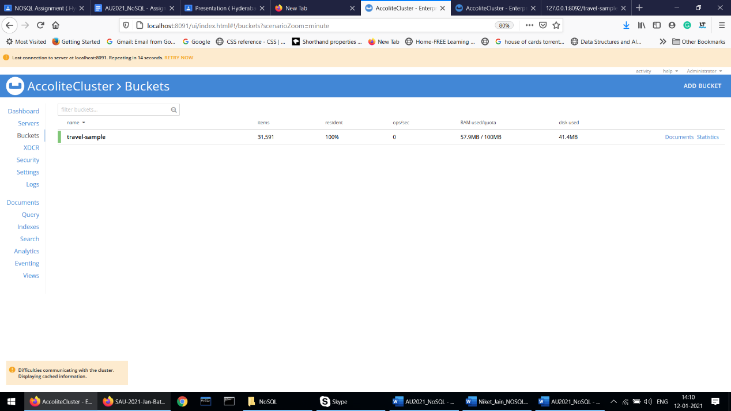

1. Write a query to get the sum of all distances where type=”route” for each airline id.

**Solution:-**

select airlineid,sum(distance) from `travel-sample` where type="route" group by airlineid;

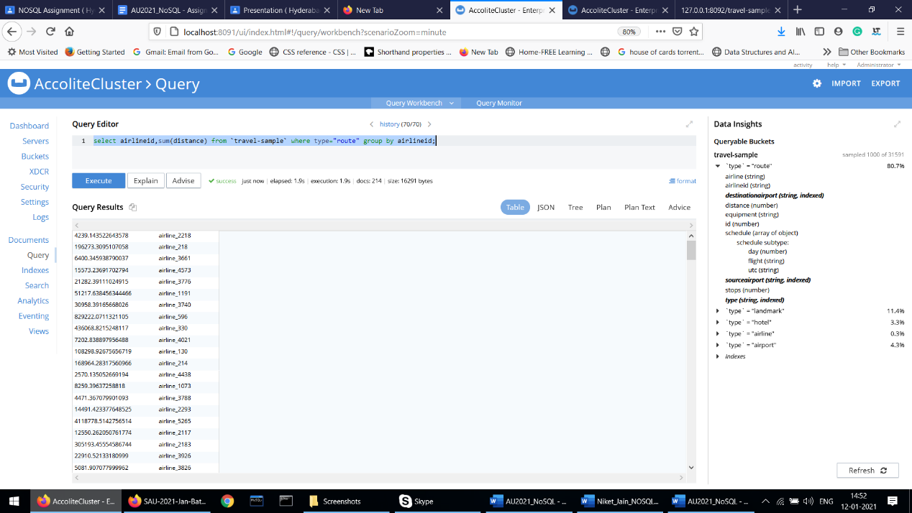

1. Write queries to join(LEFT,RIGHT,INNER) type=”route”&“airline” and fetch the data whose sourceairport=”SFO”

**Solution:-**

**a) Left Join**

select t1.airlineid,t2.otherid from (select airlineid,sourceairport from `travel-sample` where type="route") as t1 left join (select meta().id,id as otherid from `travel-sample` where type="airline") as t2 on t1.airlineid=t2.id where t1.sourceairport="SOF";

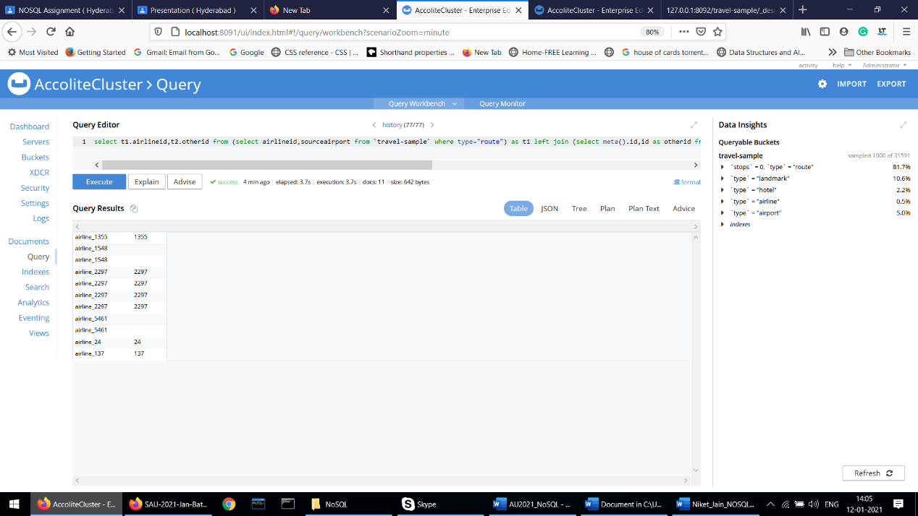

b) Right Join

select t1.airlineid,t2.otherid from (select airlineid,sourceairport from `travel-sample` where type="route") as t1 right join (select meta().id,id as otherid from `travel-sample` where type="airline") as t2 on t1.airlineid=t2.id where t1.sourceairport="SOF";

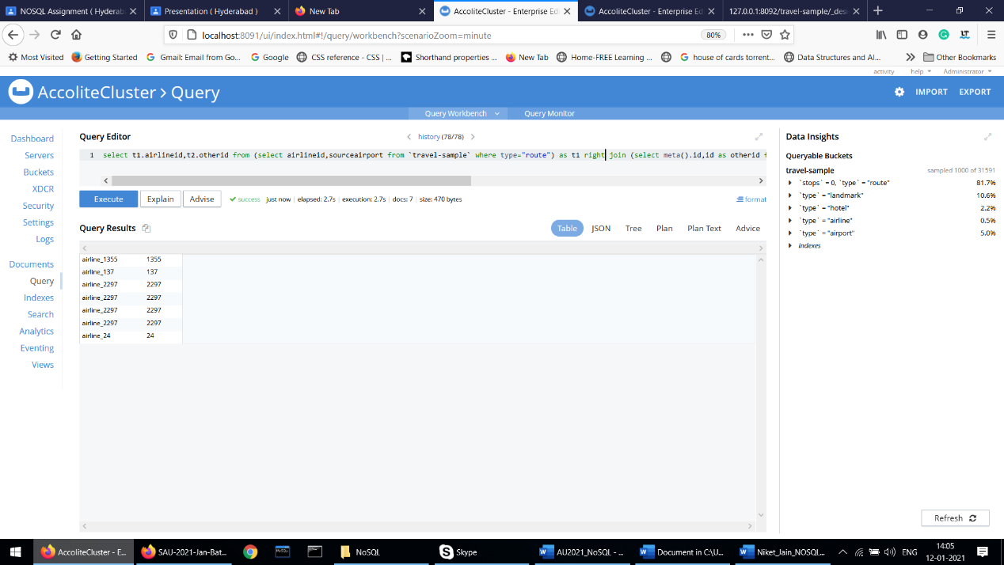

c) Inner Join

select t1.airlineid,t2.otherid from (select airlineid,sourceairport from `travel-sample` where type="route") as t1 inner join (select meta().id,id as otherid from `travel-sample` where type="airline") as t2 on t1.airlineid=t2.id where t1.sourceairport="SOF";

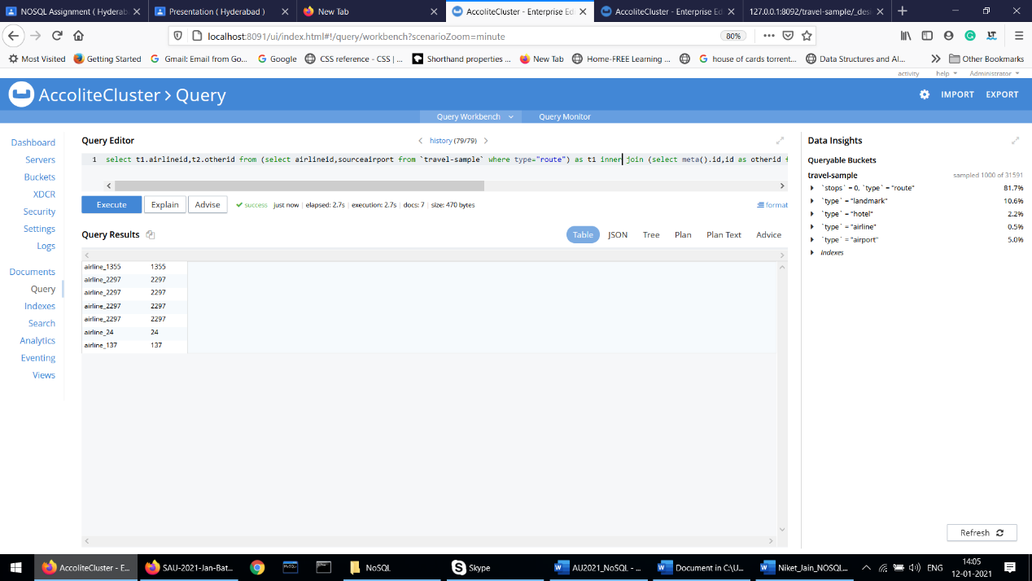

1. Write a mapreduce to get the number of all documents based on entities(type).

**Solution:-**

**Code in map**

function (doc,meta){

emit(doc.type,null);

}

// Tick group checkbox in results

**Code in reduce**

_count

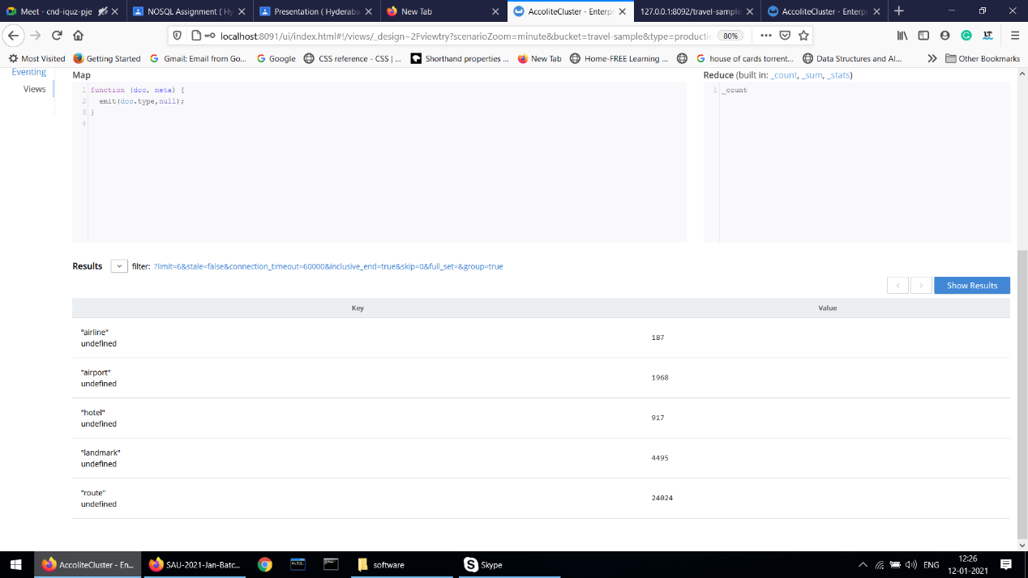

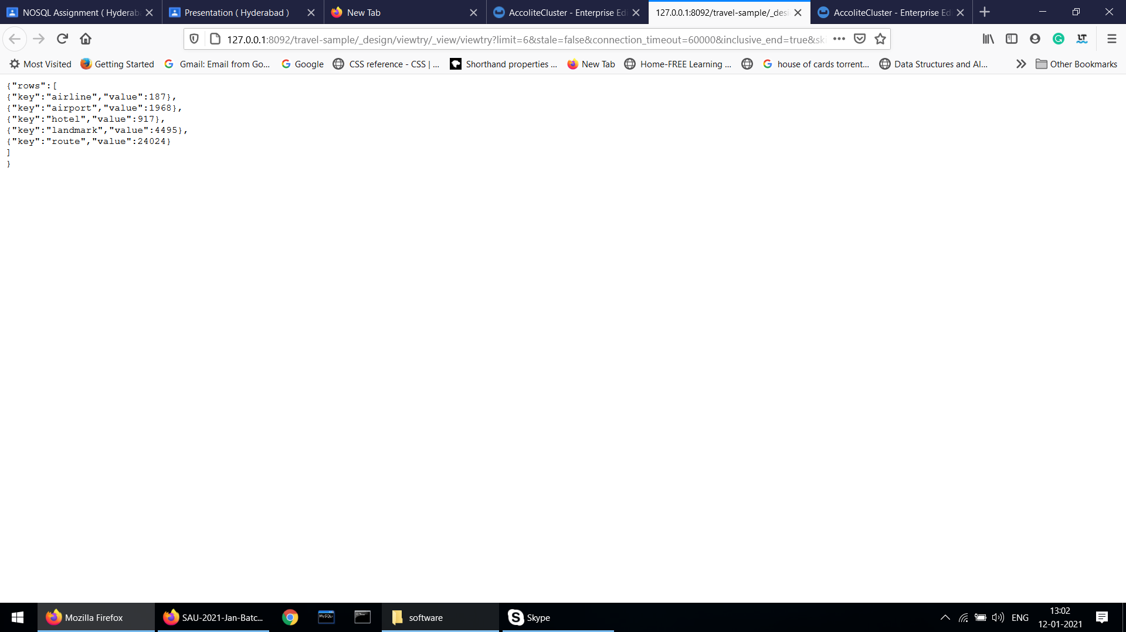

1. Refer CLI interface & try to export the travel sample data. Below are the steps:
   1. Go to Couchbase Bin folder - C:\Program Files\Couchbase\Server\bin
   2. Open Command Prompt from the bin folder

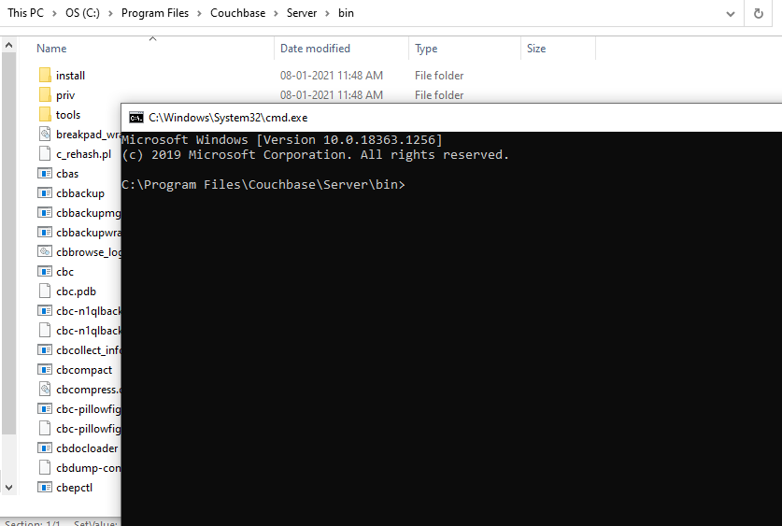

* 1. Run the below command to export the data from travel-sample bucket:

cbexport json -c couchbase://127.0.0.1 -u <USER NAME> -p <password> -b travel-sample -o C:/travelSample.json -f lines -t 4

1. Create a new Bucket “NewBucket” & import the data to it:

cbimport json -c couchbase://127.0.0.1 -u <User Name> -p <password> -b NewBucket -f lines -d file://C:/travelSample.json -t 4 -g %id%

1. Once the data is imported, please attach the screenshot.

**Solution:-**

c)

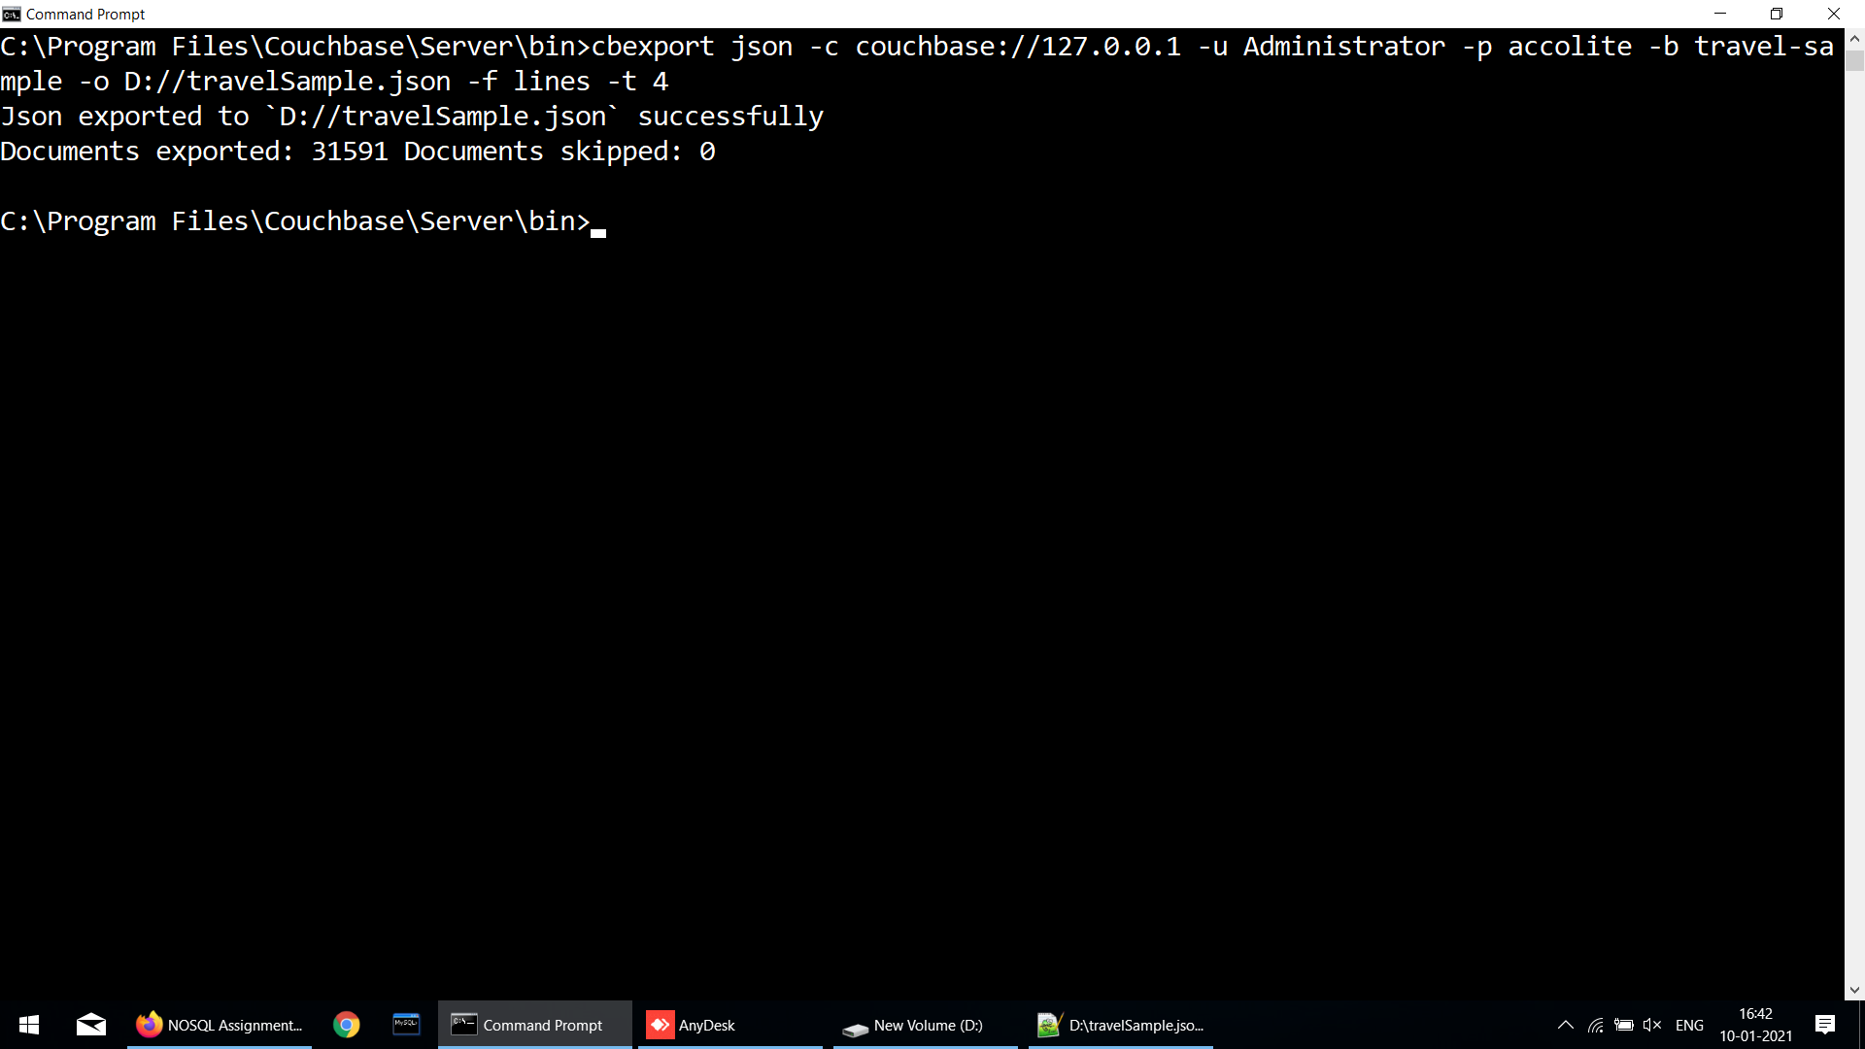

d)

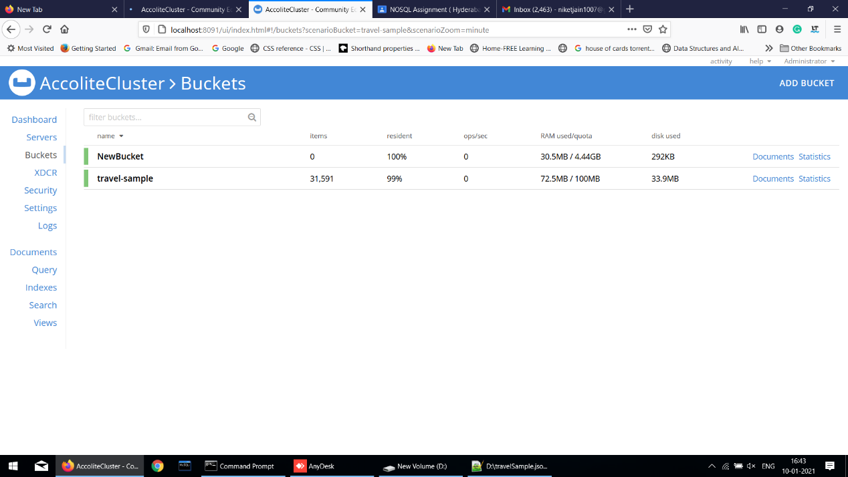

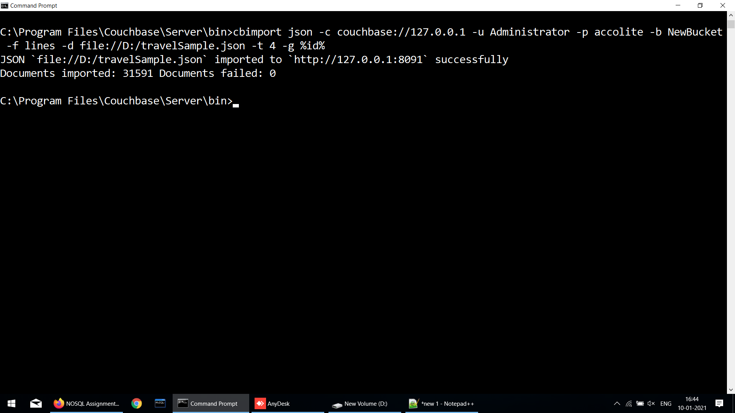

e)

